Create nonprod VCN with ORM Stack

Contents

1. Introduction 1
2. Workflow diagram to deploy the stack 1
3. Create stack for the nonprod VCN on “Default Domain” 2
4. Plan the Job 4
5. Apply the Job 5
6. Verify in the Console 7
7. Destroy the stack 9

Introduction

VCN (Virtual Cloud Network) in OCI (Oracle Cloud Infrastructure) is a software-defined network that allows customers to securely connect their cloud resources, such as Compute instances, Load Balancers, and Block Volumes, within a logically isolated virtual network.
This stack helps to creates a “ VCN” with the below properties.

A VCN is a fundamental building block for creating a network topology within an OCI tenancy. When creating a VCN, customers can specify the IP address range for the VCN, create subnets within the VCN, and configure routing rules, security lists, and other network-related components.

This stack helps to creates a “nonprod VCN” with the below properties.
- Dymanic Routing Gateways Attachments for specified VCN
- Service gateway in the specified compartment
- Private subnet in the specified VCN. Also associate a route table, security list, set of DHCP options, DNS label with the subnet.
- NAT gateway for the specified VCN
- Security lists for the specified VCN

Workflow diagram to deploy the stack
Below diagram shows how the Terraform Artifact are applied in the OCI. While creating a ORM stack, using terraform deliverables Init, Plan and Apply is the flow to provision the resource in the OCI. We can have the deliverables in any of below.
- GitLab/GitHub Repo
- Bitbucket
- Can be in folder/.zip in the local disk
- Object Storage Bucket
- Can be in compartment
- Oracle provided Template


Pre-request:
- CIDR details for the VCN and Subnet
- DRG

Create stack for the nonprod VCN on “Default Domain”

Go to OCI Console Developer Services Resource Manager Stacks select the compartment Create Stack

My Configuration Folder Browse Select the “nonprod vcn” folder that contains the terraform Upload

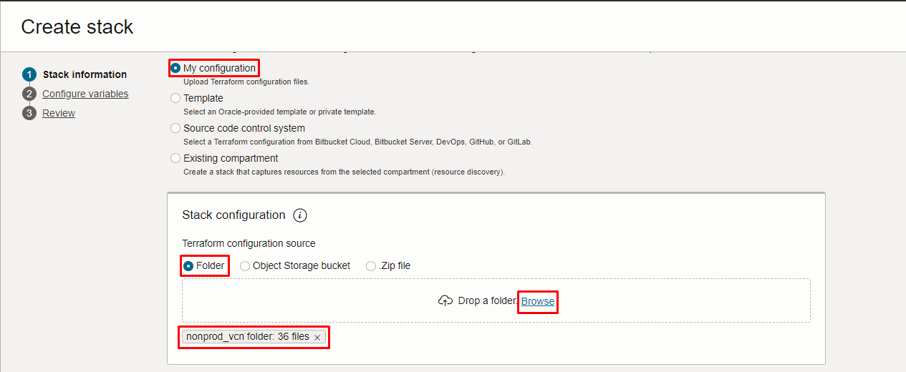
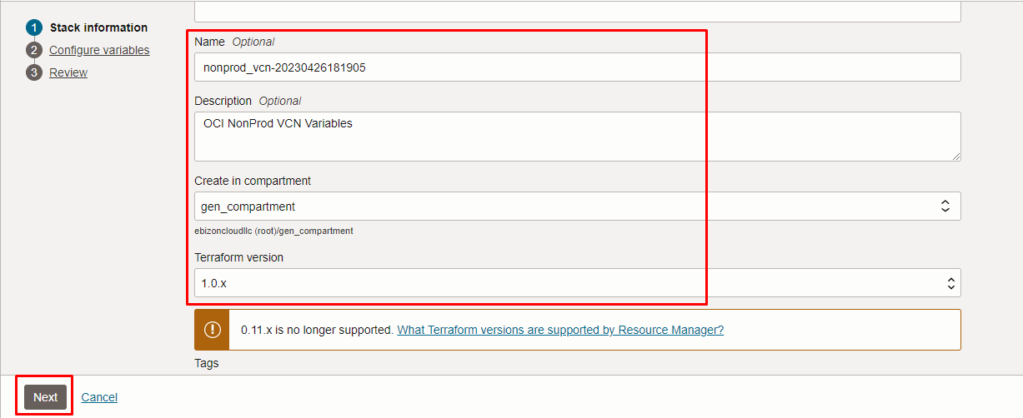

Click “NEXT”

Select the parameters as per the below screen,
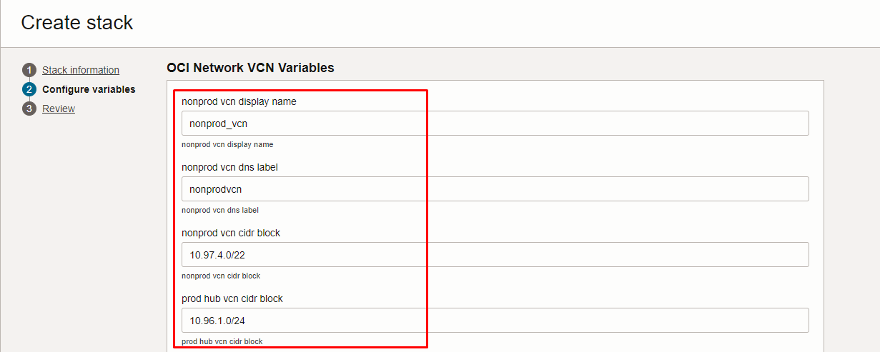
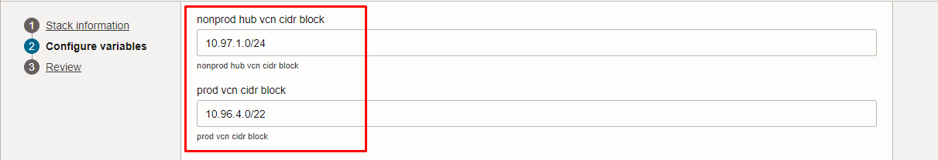
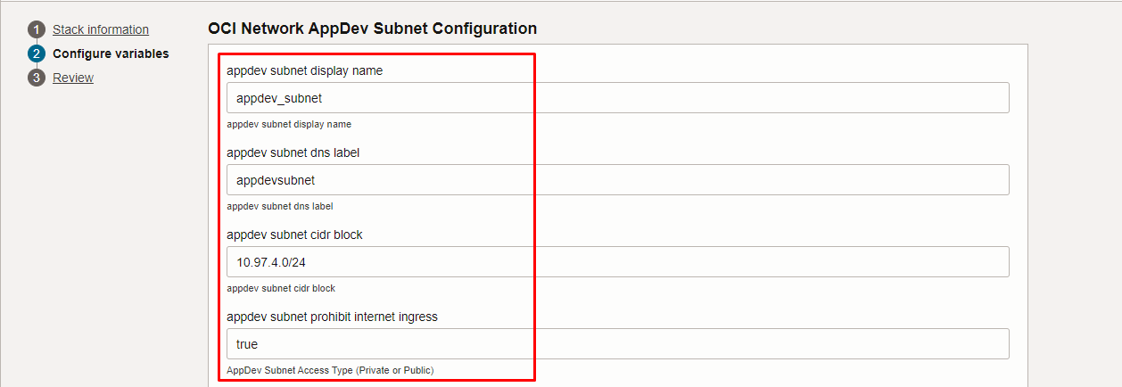
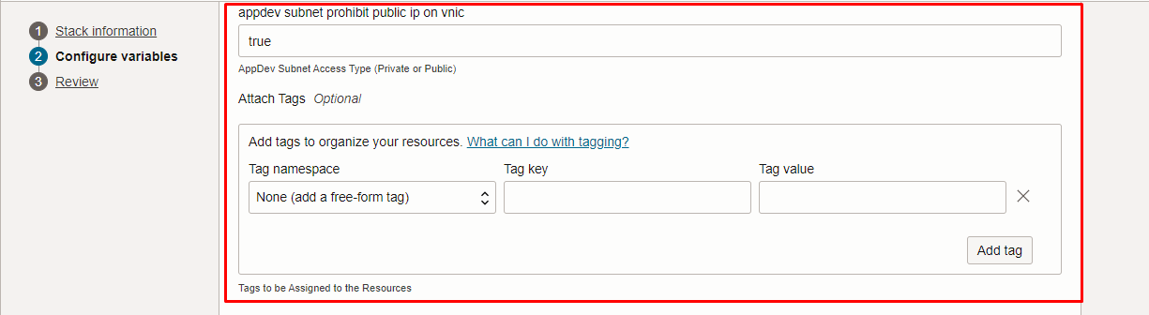
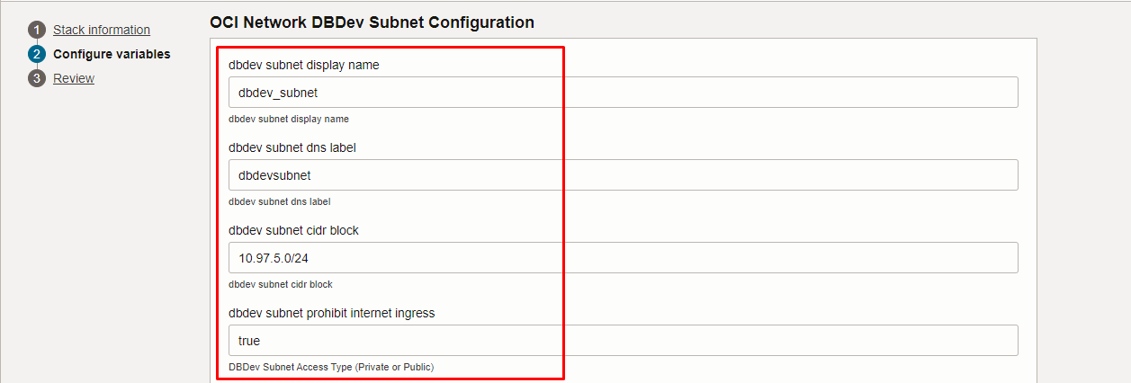
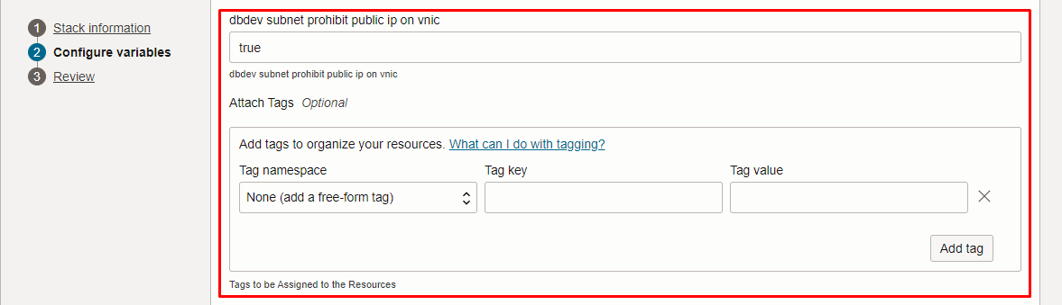
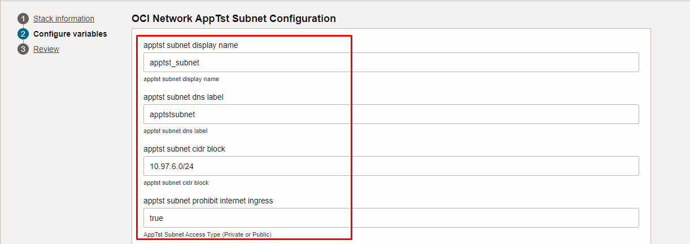
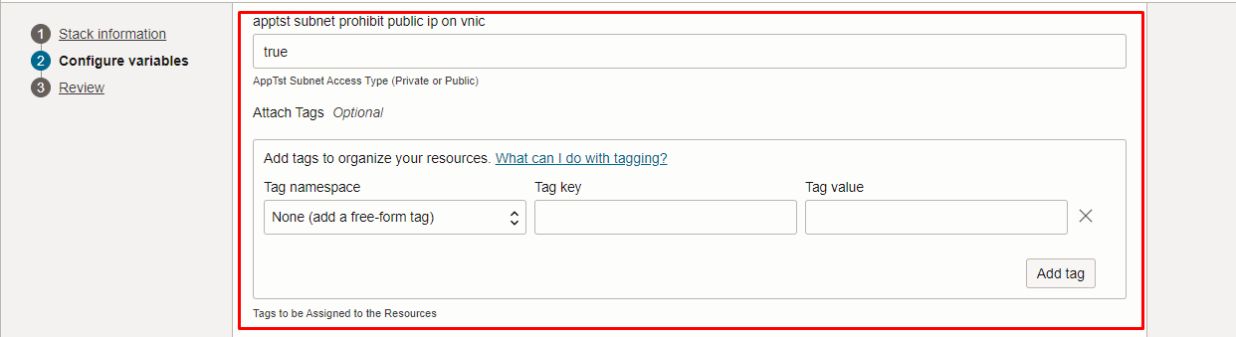
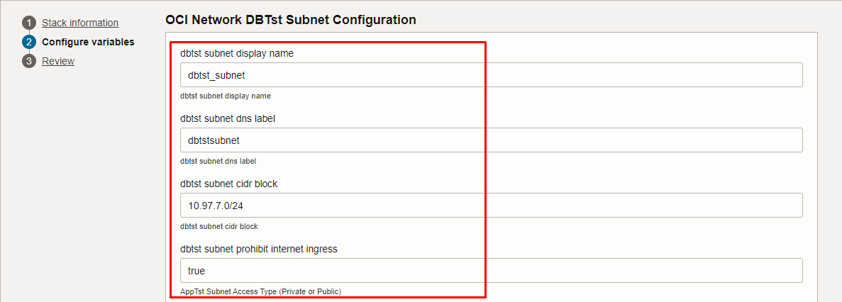
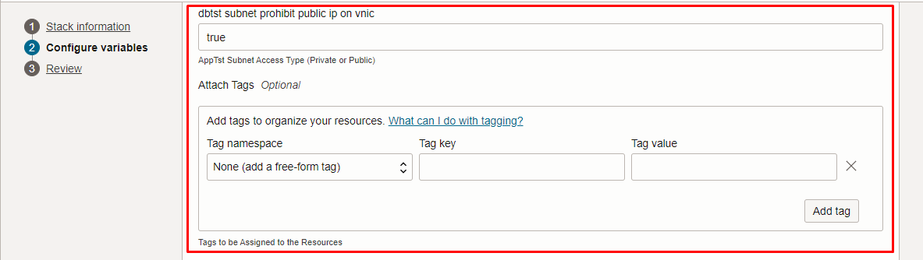
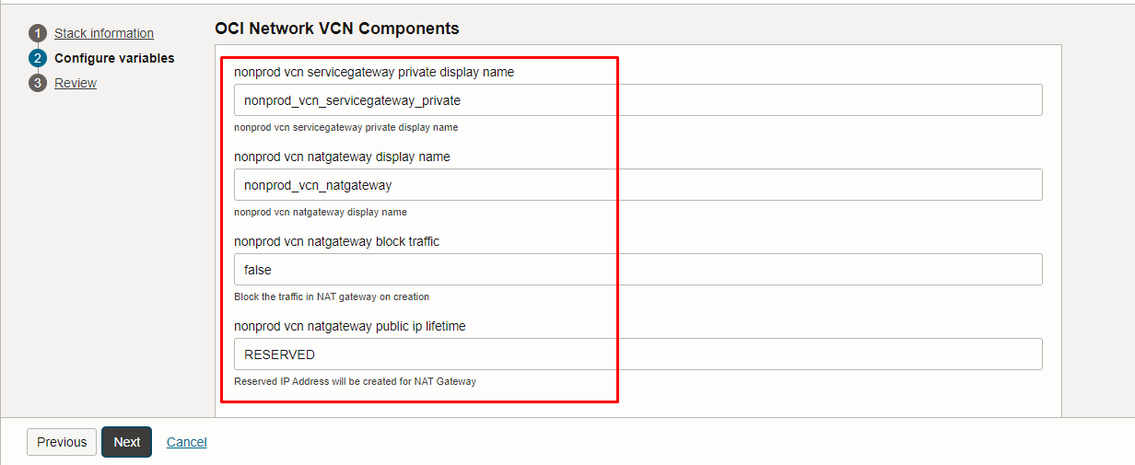
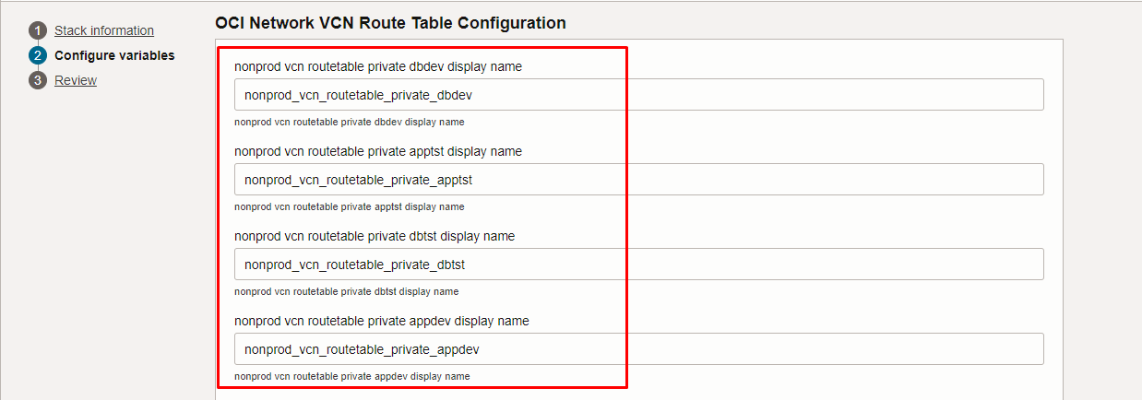
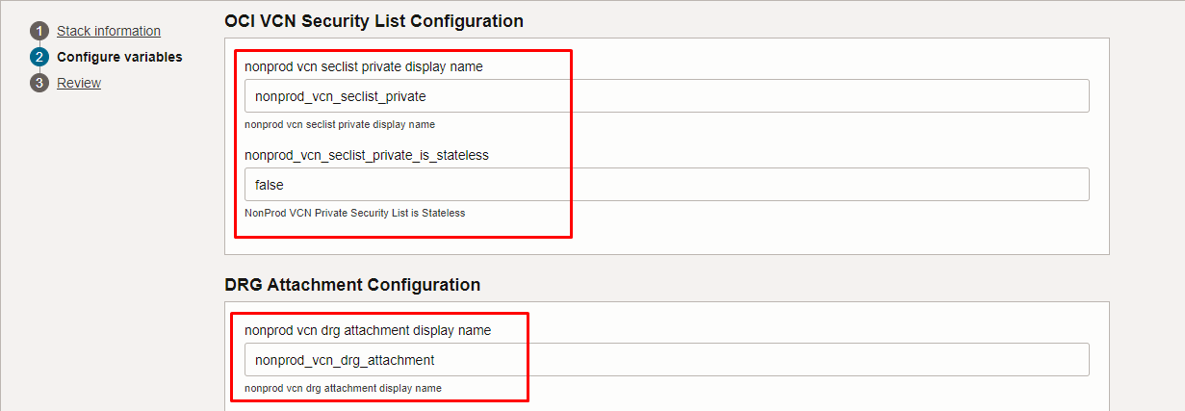
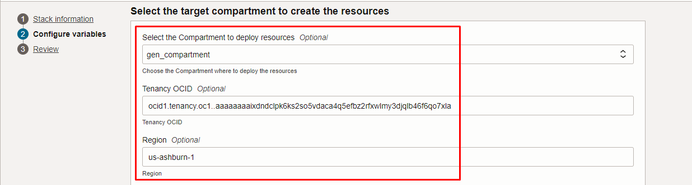
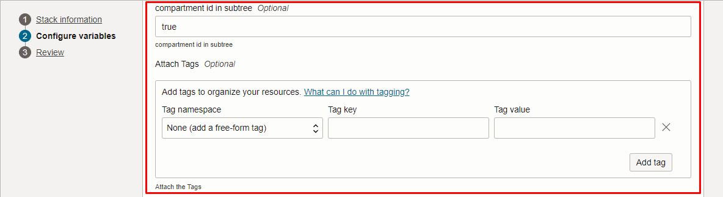
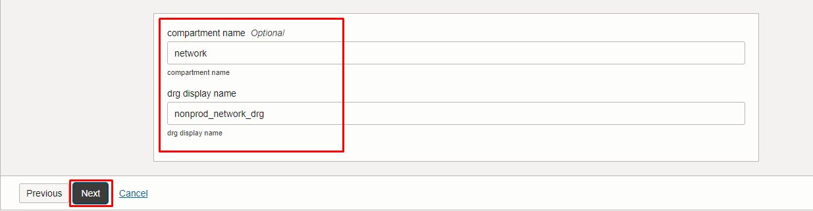

Click “NEXT” Click “CREATE”

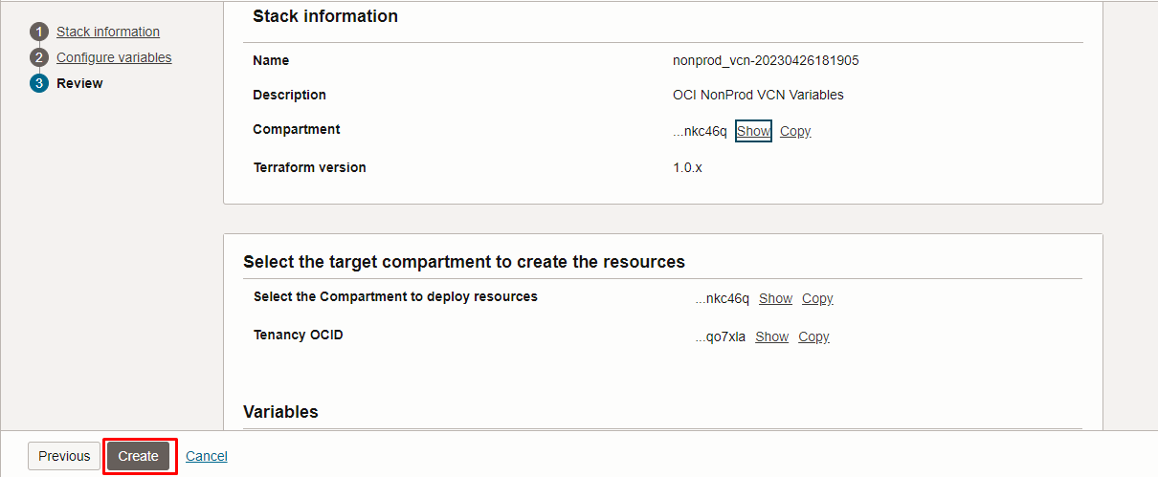

Plan the Job

Click the “Plan”

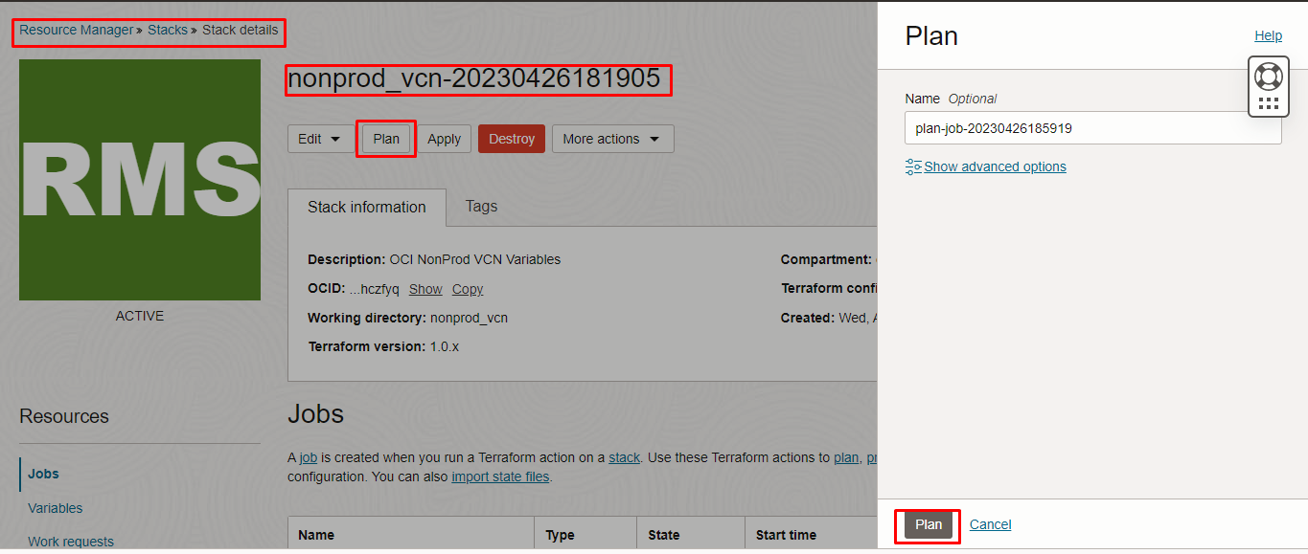

Verify the Plan is successful.

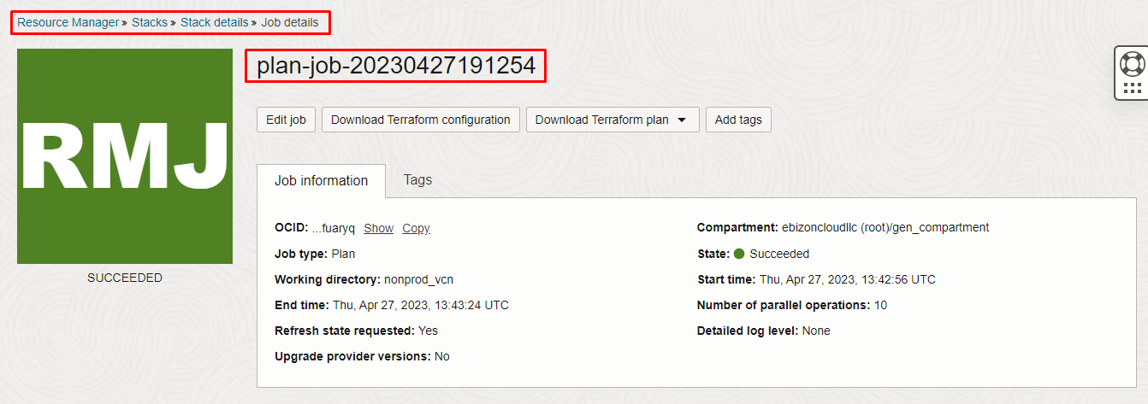

Apply the Job

Once the “plan” is success, now click “Apply”

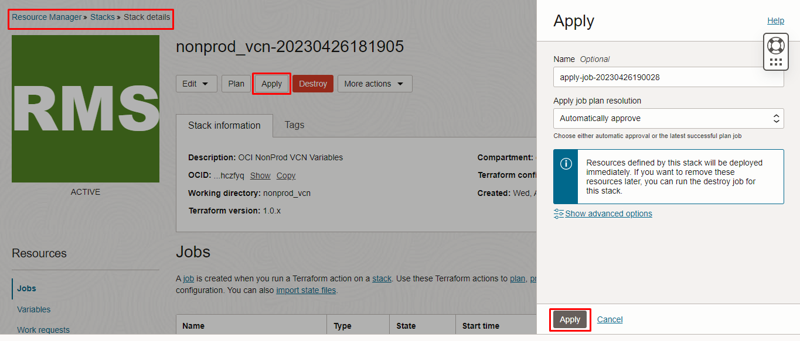

Verify the Apply is successful.

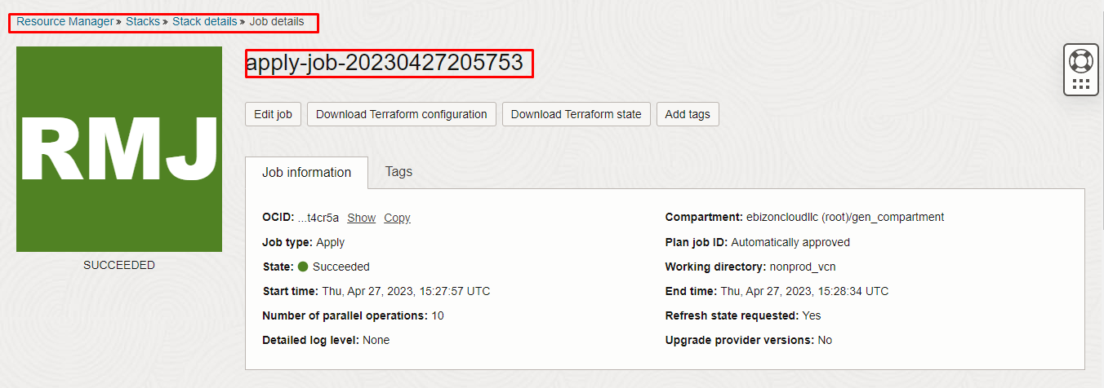

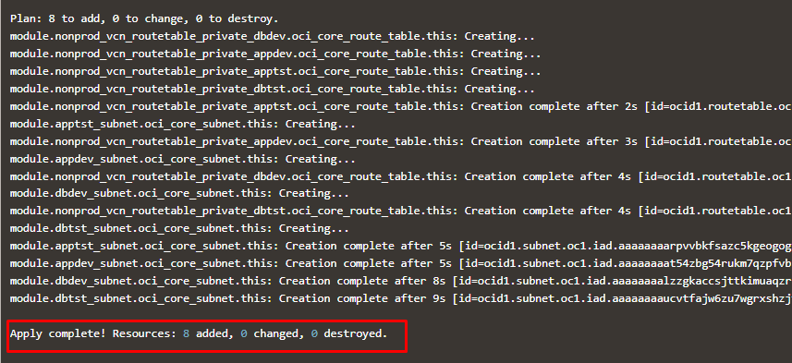

Verify in the Console

Go to OCI Console Networking Virtual Cloud Networks

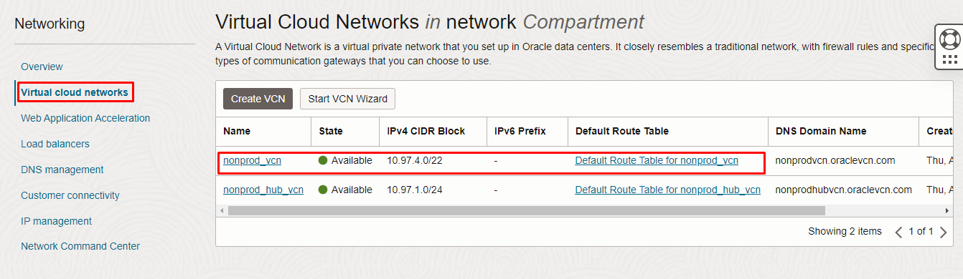

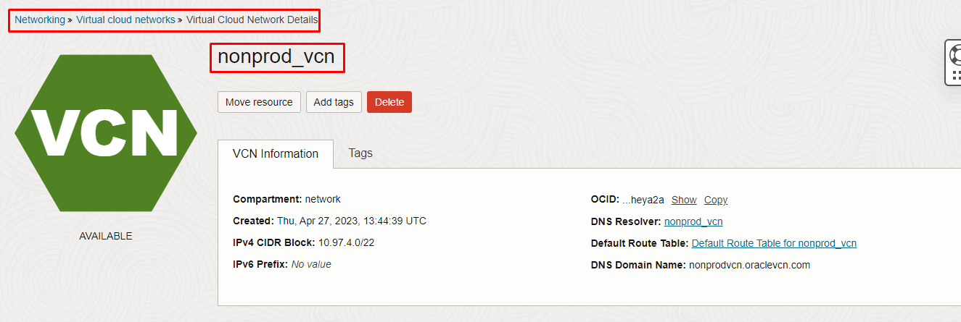
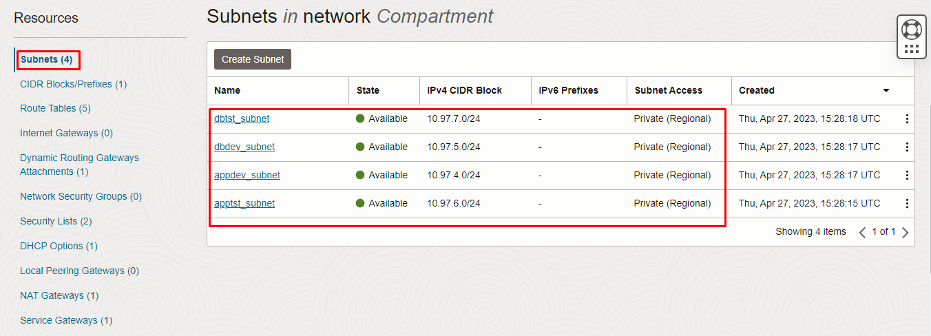
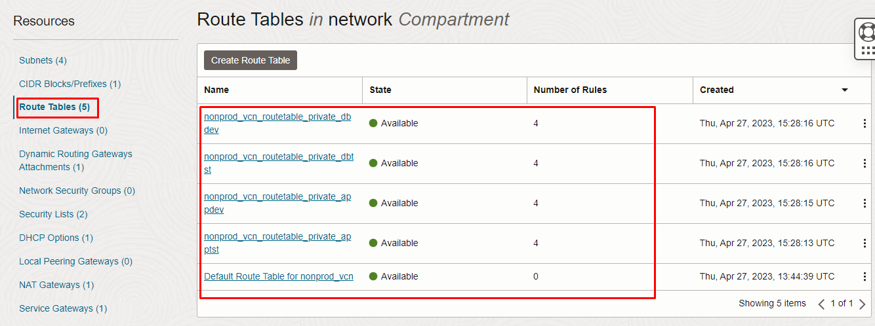
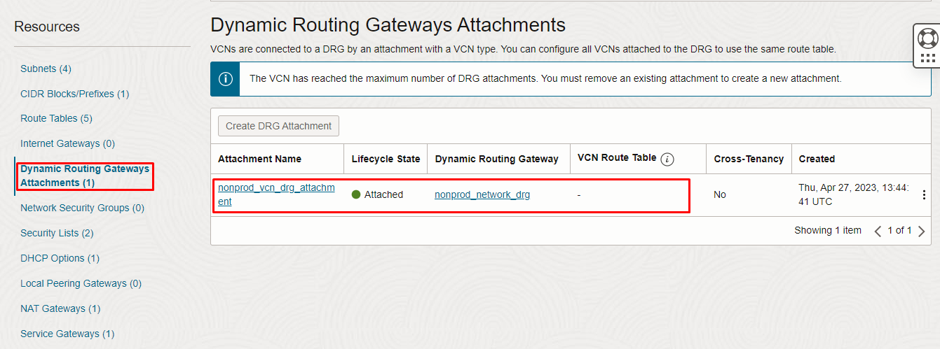
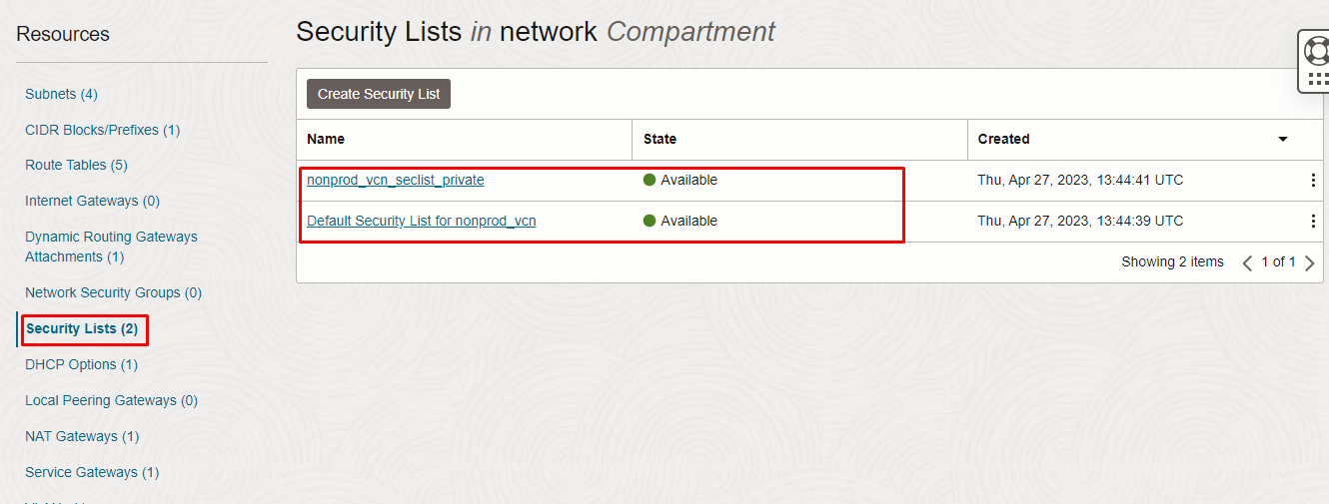
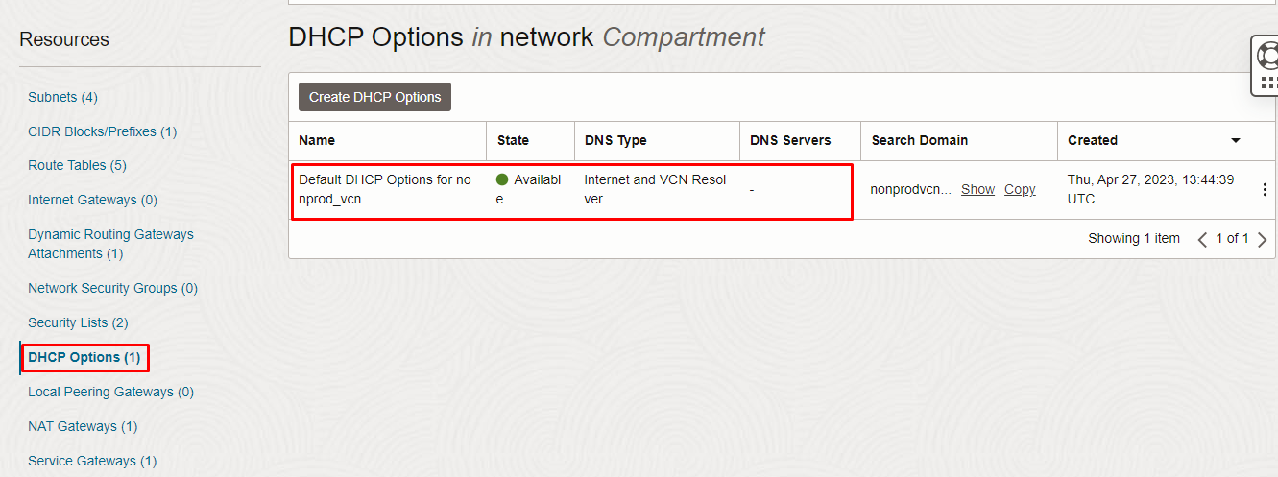
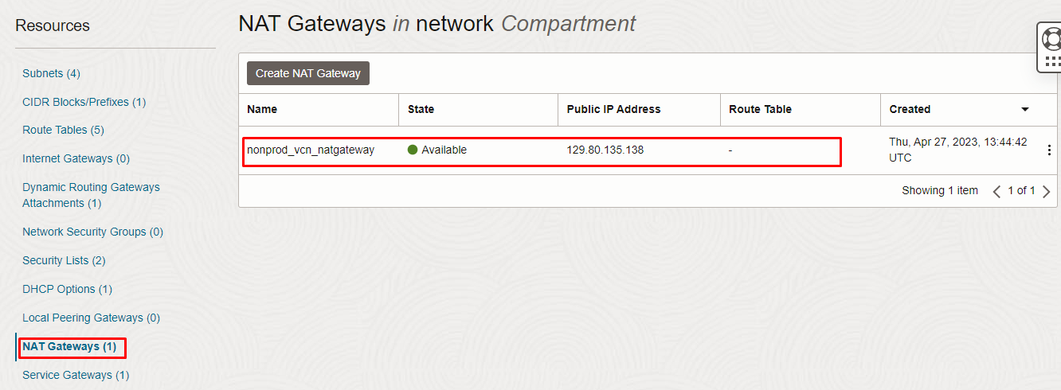
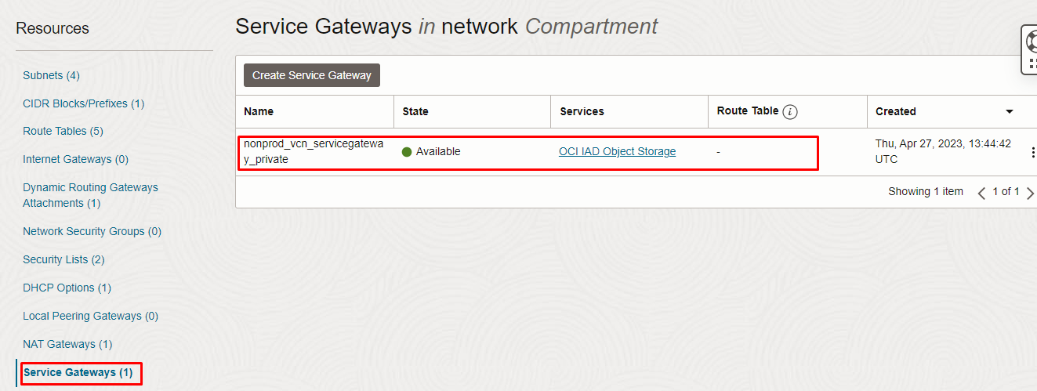

Destroy the stack

Create a destroy job in Resource Manager to release resources associated with a stack and clean up the tenancy. Once destroyed data cannot be recovered from resources.

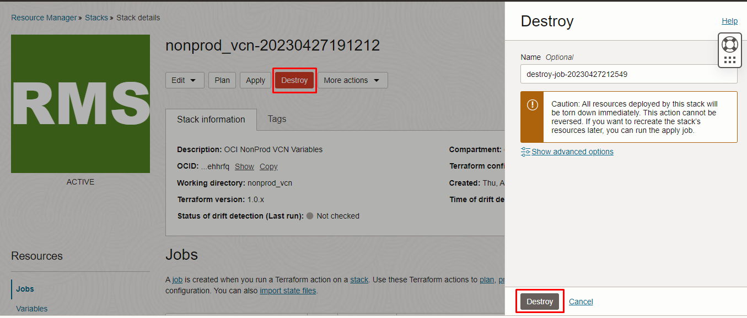

# END #

